GOVERNMENT POLYTECHNIC, PUNE-16

**(AN AUTONOMOUS INSTITUTE OF GOVERNMENT OF MAHARASHTRA)**

A Micro-project upon

“Tic – Tac - Toe Using Javascript ”

Submitted by :

2026021 Harshada Sable

2026022 Harshada Hirapure

Under the Guidance of :

Smt.S.J. Shirskar

**DEPARTMENT OF COMPUTER ENGGINERING**

**(Academic Year: 2022-2023)**

GOVERNMENT POLYTECHNIC, PUNE-16

**(AN AUTONOMOUS INSTITUTE OF GOVERNMENT OF MAHARASHTRA)**



CERTIFICATE

This is to certify that **Harshada Hirapure and Harshada Sable**  of class Third Year (2022-2023) has completed a micro-project on “Tic-Tac-Toe in javascipt” under the guidance of Mrs. Shirskar in partial fulfillment of the requirement for the award of diploma in computer engineering from Government Polytechnic, Pune.

**Mrs. S.J.Shirskar Prof. M.Kokate Dr.V.S.Bandal**

(Project Guide) (Head of Department) (Principal)

**ACKNOWLEDGEMENT**

I take this opportunity to present my votes of thanks to all those guidepost who really acted as lightening pillars to enlighten our way throughout this project that has led to successful and satisfactory completion of this study. We are really grateful to our HOD Mrs. M.U.Kokate for providing us with an opportunity to undertake this project in this university and providing us with all the facilities. We are highly thankful to Smt. Shirskar for her active support, valuable time and advice, whole-hearted guidance, sincere cooperation and pains- taking involvement during the study and in completing the assignment of preparing the said project within the time stipulated. Lastly, We are thankful to all those, particularly the various friends, who have been instrumental in creating proper, healthy and conductive environment and including new and fresh innovative ideas for us during the project, their help, it would have been extremely difficult for us to prepare the project in a time bound framework.

**ABSTRACT**

In the fast growing field of software engineering and development and even more rapidly growing sector of game development the future is hard to predict. In general software project is a project focusing on the creation of software. Consequently, Success can be measured by taking a look at the resulting software. In a game project, the product is a game. But and here comes the point: A game is much more than just its software. It has to provide content to become enjoyable. Just like a web server: without content the server is useless, and the quality cannot be measured. This has an important effect on the game project as a whole. The software part of the project is not the only one, and it must be considered in connection to all other parts: The environment of the game, the story, characters, game plays, the artwork, and so on.

The Tic Tac Toe game is a game for two players, called "X" and "O", who take turns marking the spaces in a 3×3 grid. The player who succeeded in placing three respective marks in a horizontal, vertical, or diagonal row wins the game. The Tic Tac Toe is a great way to pass your free time whether you're standing in a line or spending time with your kids. Stop wasting paper and save trees. Because of the simplicity of Tic Tac Toe, it is often used as a pedagogical tool for teaching the concepts of good sportsmanship and the branch of artificial intelligence.

**CONTENTS**

1. TIC- TAC –TOE
2. OBJECTIVE
3. REQUIREMENTS
4. SYSTEM DESIGN
5. SNAPS OF PROJECT OUTCOME
6. LIMITATIONS
7. FUTURE SCOPE
8. CONCLUSION
9. REFERENCES
10. **TIC-TAE-TOE**

Playing Tic-Tac-Toe is quick, easy, and fun. It’s the game for everyone. While most people call it Tic-Tac-Toe, it also goes by “Noughts and Crosses”.Something that’s really interesting about Tic-Tac-Toe is that many countries refer to it fondly by other names completely, even though they also know it as Tic-Tac-Toe. Take, for instance, Norway, where it is called “Twiddles and Bears” or Ireland, where it is called “Xs and Os” and “Boxin Oxen”.

Tic taco toe’s history started with the Romans, but their version was, admittedly, much more difficult than the one we know today. Each player used 3 pebbles, and so had to move them around on each turn. Tic tac toe’s markings have been found etched all over Rome.

Because of its simplistic format and potential for a game of almost any size, there are many possibilities for tic tac toe variations.

Other popular examples of tic tac toe variations include Mojo, Toss Across, Nine Men’s Morris, Quarto, and Gobblet, among many others.

1. **OBJECTIVE**

The game is developed for full-time entertainment and enthusiasms. It teaches the Gamer to be alert at every situation he/she faces, because if the Gamer is not fully alert and notice the saucer fire he/she must be hit by the saucer-bombs. Though the proposed game is an action game, it doesn’t involve direct violence. No zombie killing, animal killing, or human killing is performed in the game. So it can also be viewed as a nonviolence game. Kids can also play this game, because the design of the game is very simple, controlling the game is very easy – pressing some neighboring keys of the keyboard.

The purpose of this research is to provide a virtual image for the combination of both structured and unstructured information of my project “Tic Tac Toe”. This is a single-player strategy game on the Windows platform. The player will progress through levels which require precise manipulation of the environment, though the game Encourages creativity and daring via branching pathways. The episodic structure of the game facilitates the pace of the story. I demonstrate the action flow between inputs, script, display (output).

1. **REQUIREMENTS**
   1. System requirements

Most of the computer games require high configurations of computer. But in the case of the proposed gaming system, the system requirements is not that much. The minimum systems requirements for the proposed project “Tic Tac Toe” game is mentioned following.

1. Operating System: Android 4.0
2. Processor: 1.2 GHz
3. RAM: 512MB
4. Storage: 100 MB

3.2 Software requirements

1. IDE
2. Knowledge about javascript , css and html
3. **SYSTEM DESIGN**

Our project name is Tic-Tac-Toe game. This game is very popular and is fairly simple by itself. It is actually a two player game. In this game, there is a board with n x n squares. In our game, it is 3 x 3 squares. The goal of Tic-Tac-Toe is to be one of the players to get three same symbols in a row - horizontally, vertically or diagonally - on a 3 x 3 grid.

This game can be played in a 3x3 grid (shown in the figure 2.1) .The game can be played by two players.

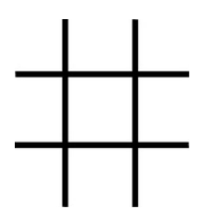

Figure 2.1

Theory of game :

A player can choose between two symbols with his opponent, usual games use “X”and “O”. If first player choose “X” then the second player have to play with “O” and vice versa.

A player marks any of the 3x3 squares with his symbol (may be “X” or “O”) and his aim is to create a straight line horizontally or vertically or diagonally with two intensions:

a) Create a straight line before his opponent to win the game.

b) Restrict his opponent from creating a straight line first.

In case logically no one can create a straight line with his own symbol, the game results a tie.

Hence there are only three possible results – a player wins, his opponent (human or computer) wins or it’s a tie.

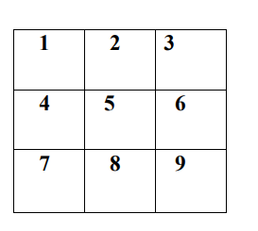

If any player is able to draw three Xs or three Os in the following combinations then that player wins. The combinations are:

a) 1, 2, 3 b) 4, 5, 6

c) 7, 8, 9 d) 1, 4, 7

e) 2, 5, 8 f) 3, 6, 9

h) 1, 5, 9 i) 3, 5, 7

Core logic :

For each move, check whether any 3 combination is occupied by any player and display the winner accordingly

There is one HTML file for webpage and one stylesheet file for providing design to webpage and javascript file for logic to apply

Functions used in javascript to :

1. myfunc() :- To set the DOM to input field. To check is player one won or two by applying multiple if else conditions including a condition to check whether the game is tie
2. myfunc_2() : - To reset the game
3. myfunc-3() to myfunc_11() :- to check turn of the player and put accordingly x or 0
4. **snaps of project outcome**

Interface

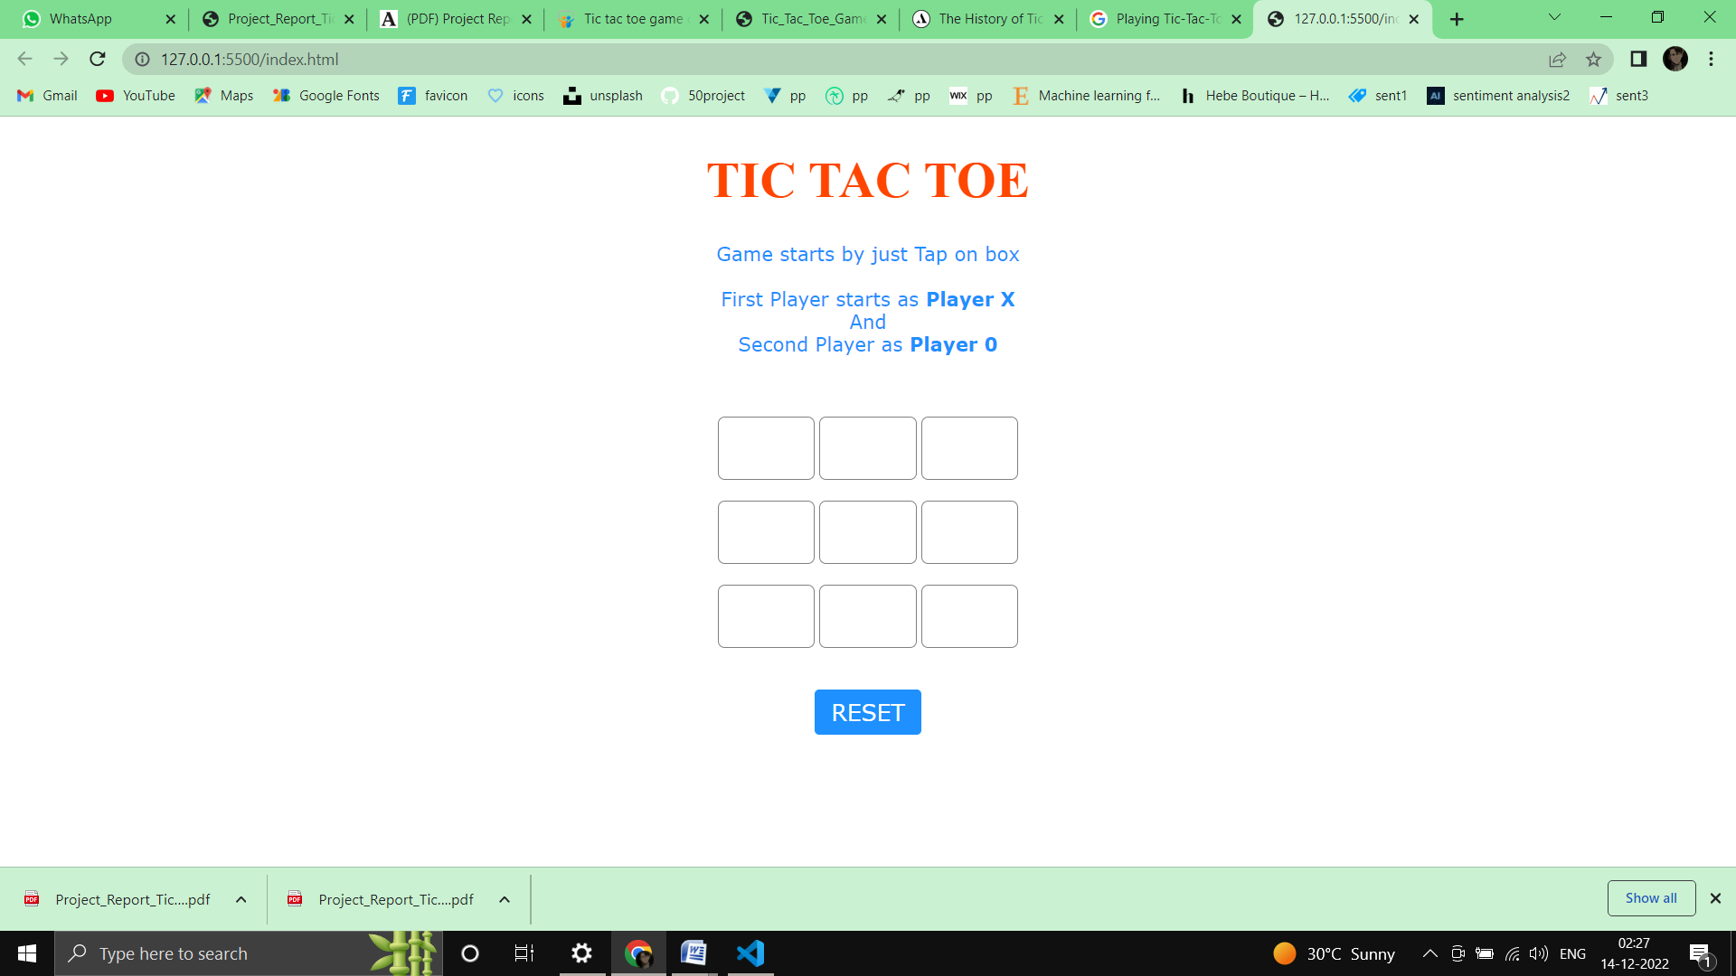

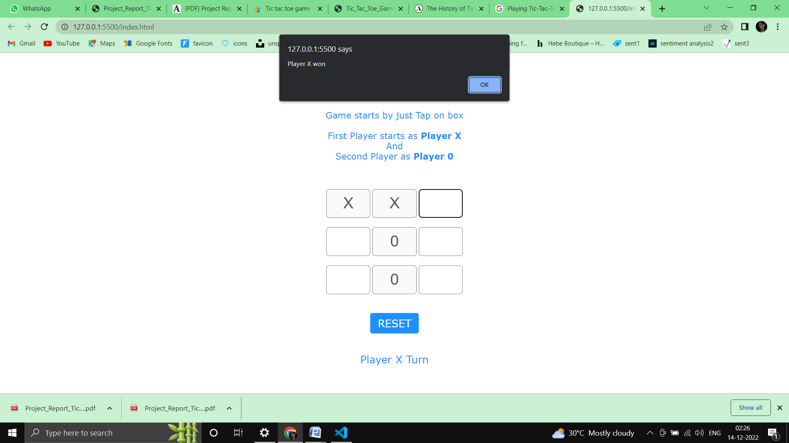Player x won :

Player 0 won :



1. **LIMITATIONS**

1. GUI is not so attractive.

2. Only mouse interface is implemented, keyboard is not activated in the game.

1. **FUTURE SCOPE**

1. Keyboard functions will be added.

2. We want to design more complex boards for the game in future

1. **CONCLUSION**

The Tic Tac Toe game is most familiar among all the age groups. Intelligence can be a property of any purpose-driven decision maker. This basic idea has been suggested many times. An algorithm of playing Tic Tac Toe has been presented and tested that works in efficient way. Overall the system works without any bugs.

1. **REFERENCES**
2. <https://www.academia.edu/28164640/Project_Report_Tic_Tac_e>
3. <https://www.slideshare.net/thanksforvisitinghere/tic-tac-toe-game-code>
4. <https://www.geeksforgeeks.org/simple-tic-tac-toe-game-using-javascript/>